# CS 255 System Design Document – Austin Henley

## UML Diagrams

### UML Use Case Diagram

### UML Activity Diagrams

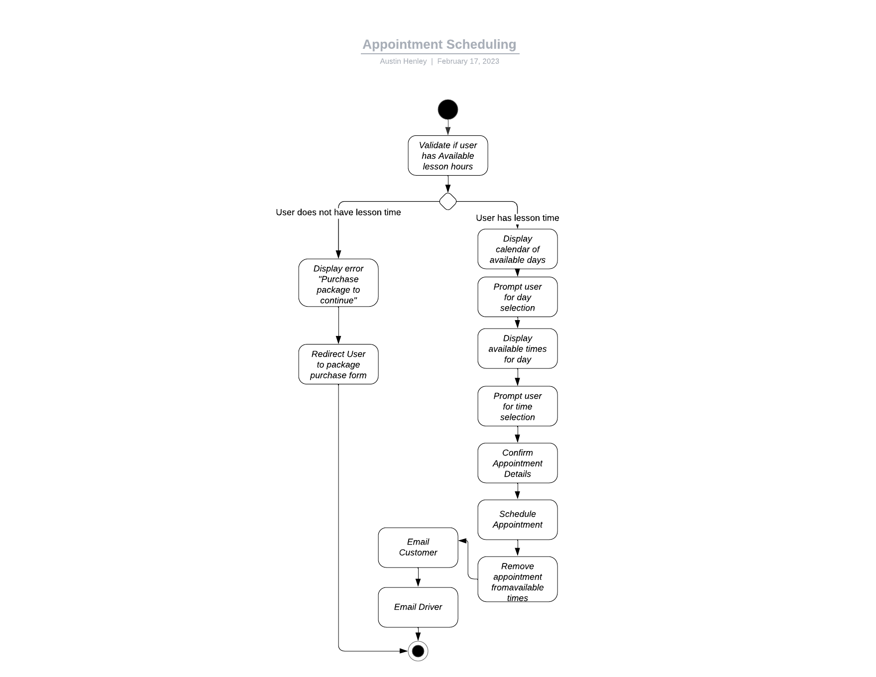

### UML Sequence Diagram

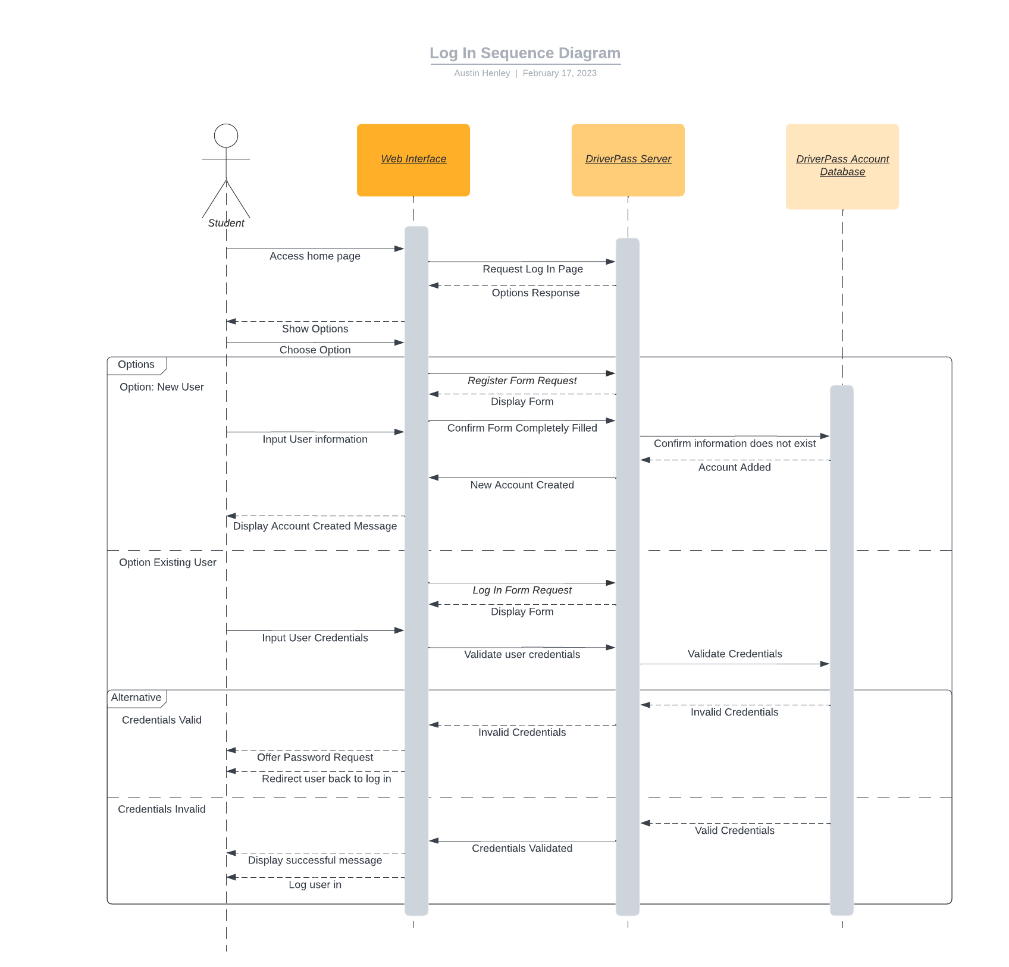

### UML Class Diagram

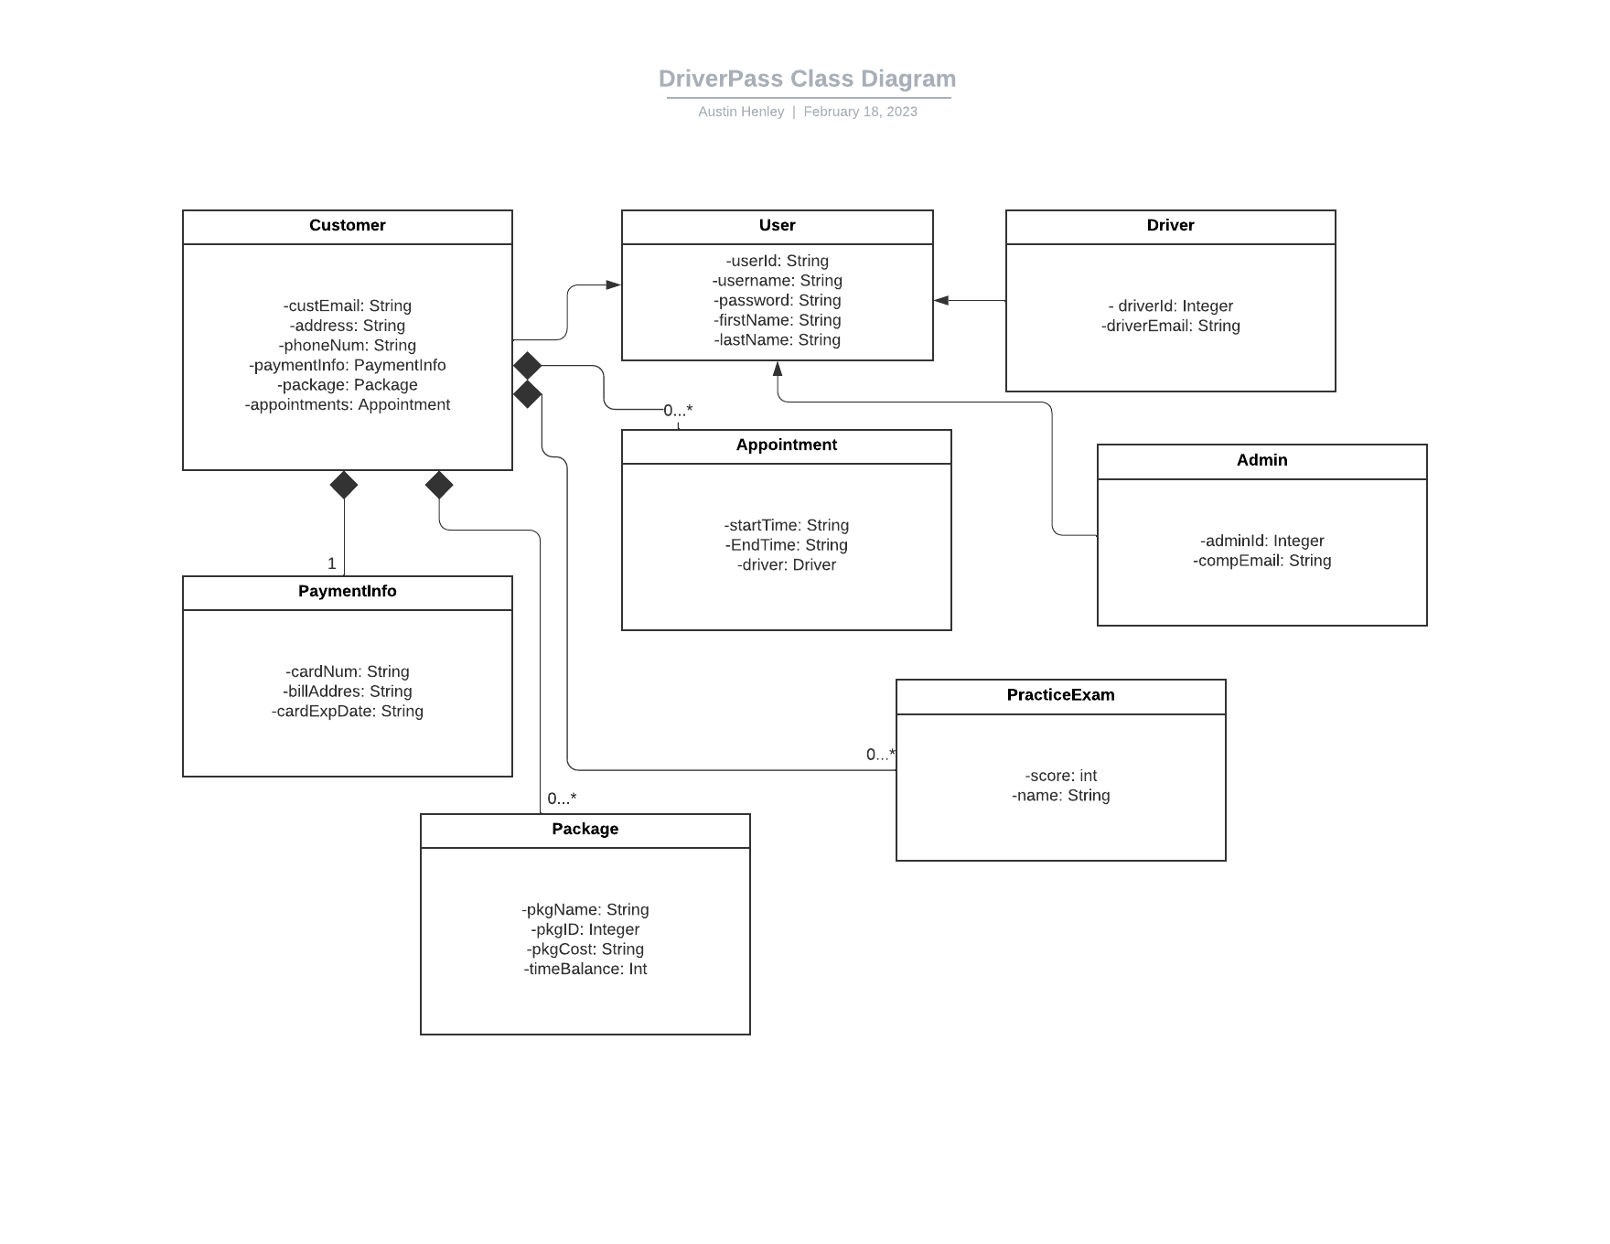

## Technical Requirements

* This system is web-based and will need to be hosted utilizing a cloud-service provider.
  + Cloud-based infrastructure will be utilizing Linux servers, so Linux expertise will be a must.
* Due to system being server-based, access to high-speed internet will be necessary.
  + Consistent internet connection is important for this environment.
* Necessary equipment will be needed to be able to test user experience from multiple devices.
  + Desktop
  + Tablet
  + Smartphone
* For managing multiple users with different access types, a tool will be necessary to manage user roles.
* To create the system, an IDE will be necessary to write the code.
  + Language of choice may be Java, and in that case the IDE would be Eclipse.
* At least one database will be needed to store user information.